Creating EC2 Instance in AWS

using Terraform

INTRODUCTION OF EC2

**EC2** (Elastic Compute Cloud) is a web service provided by Amazon Web Services (AWS) that offers scalable virtual server instances for running applications in the cloud. It allows users to launch and manage virtual machines, known as "instances," on demand. EC2 provides flexible computing resources, letting users choose the type of instances, operating systems, and configurations that best suit their needs.

* Key features of EC2 include:

1. **Scalability**: You can easily scale up or down by launching new instances or terminating existing ones.
2. **Variety of Instance Types**: EC2 offers different types of instances optimized for specific use cases, such as compute-intensive tasks, memory-optimized tasks, or general-purpose applications.
3. **Security**: EC2 provides features like virtual firewalls (security groups), key pairs for SSH access, and integration with AWS Identity and Access Management (IAM) for secure instance management.
4. **Elastic IPs**: Static IP addresses that can be associated with your instances, allowing

for more reliable connections.

1. **Auto Scaling**: Automatically adjusts the number of running EC2 instances based on traffic demand.
2. **On-demand and Reserved Pricing**: You can choose to pay for instances on an on- demand basis or reserve instances for lower costs.

Step 1: Install Terraform

* + Download and install Terraform from the official website:
  + https:[//w](http://www.terraform.io/downloads)ww[.terraform.io/downloads.](http://www.terraform.io/downloads)
  + Follow the instructions to install it on your system.

Step-2 creating aws access key

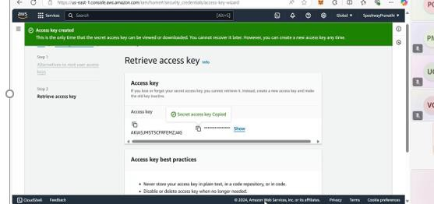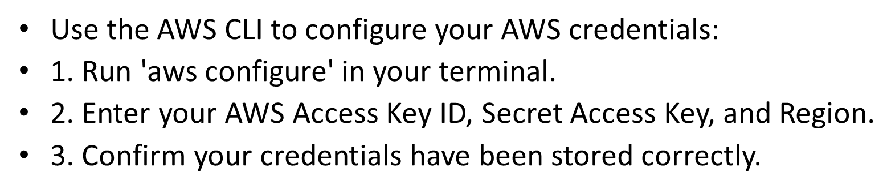

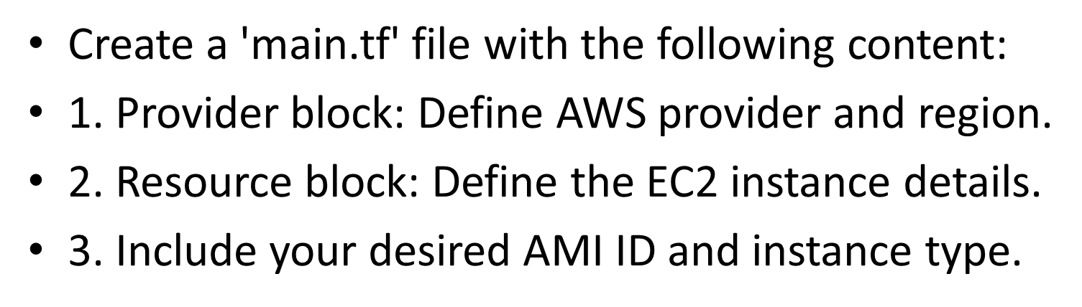Step 3: Write Terraform Configuration

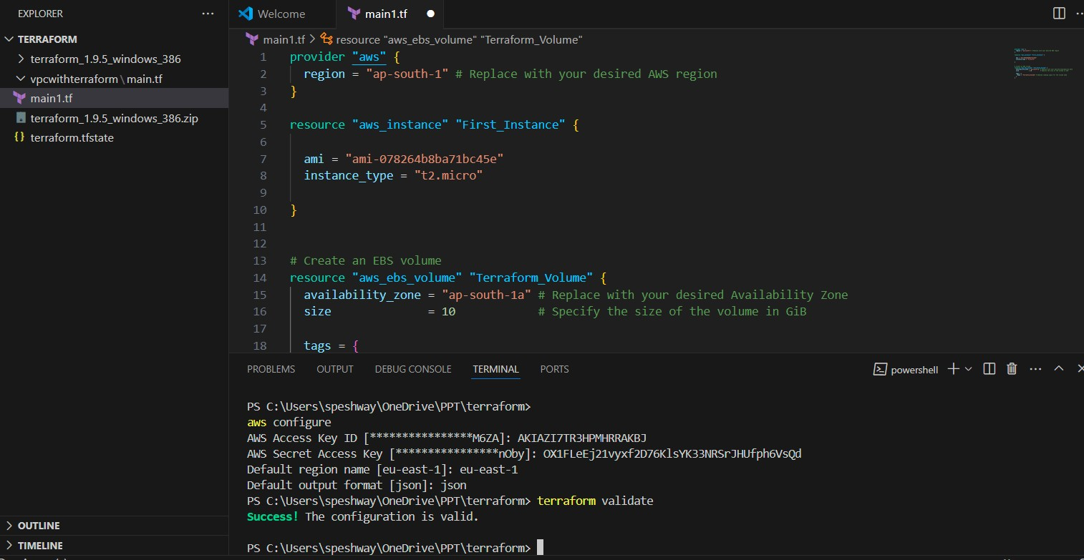

Step 4: Initialize Terraform

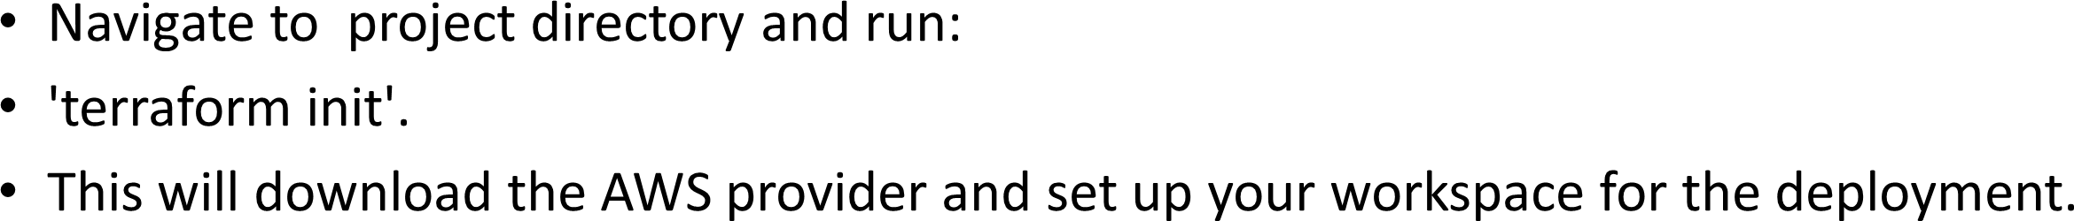

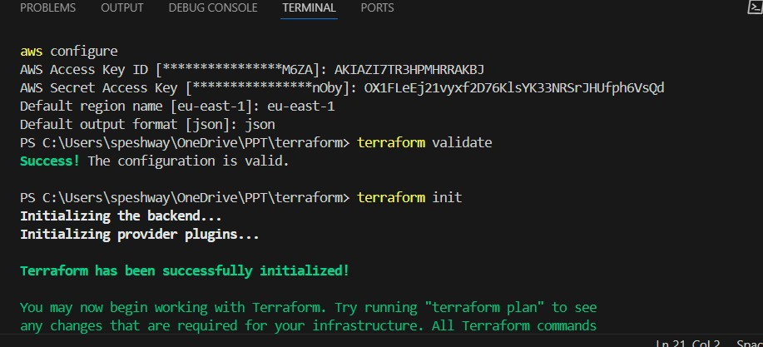

Step 5: Apply Terraform Plan

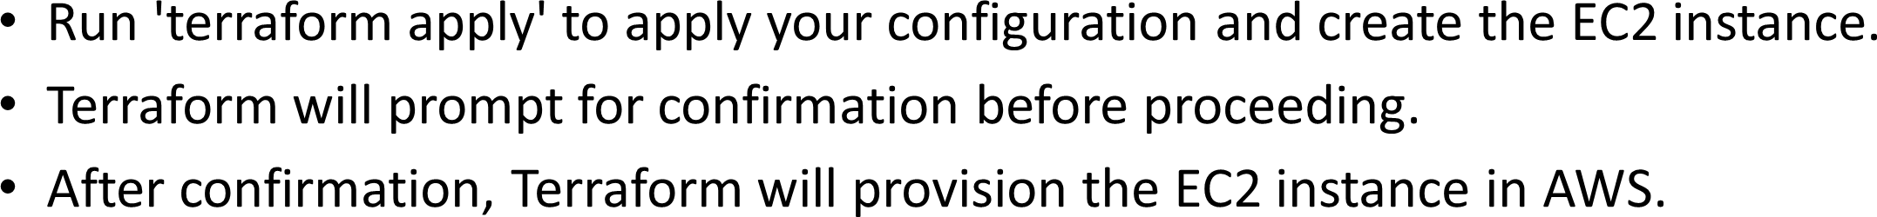

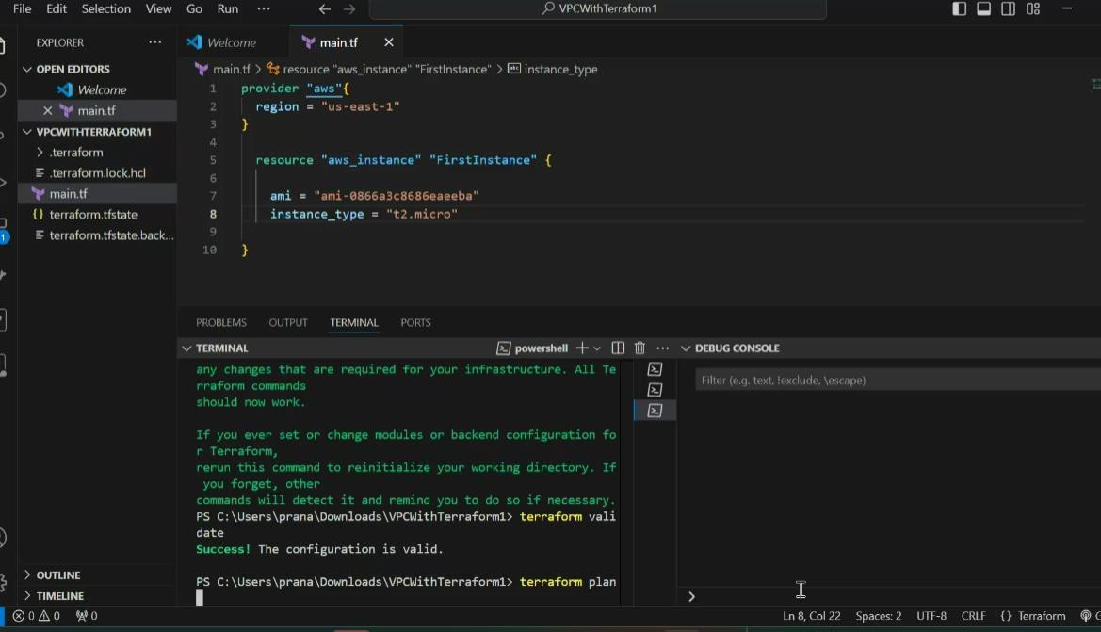

Step 6: Verify EC2 Instance in AWS



